Lab 3 — Software Requirements Specification (SRS)

Project: TaskFlow – Team Productivity & Task Management Web App
Group: 14
Members: Trịnh Văn Đức – ITITIU21182
Mai Quốc Bình – ITDSIU21077
Lưu Trung Đức - ITDSIU20003

1. Introduction
1.1 Purpose
This SRS defines functional and non-functional requirements for TaskFlow. It ensures a shared understanding among developers, testers, and stakeholders.
1.2 Scope
TaskFlow is a web-based team productivity application allowing users to create, assign, and track tasks, communicate through comments, and visualize progress.
1.3 Definitions, Acronyms, Abbreviations
- FR – Functional Requirement
- NFR – Non-Functional Requirement
- JWT – JSON Web Token
- REST API – Representational State Transfer Application Programming Interface.
1.4 References
- Lab 2 Vision & Scope (Group 14)
- Trello Board
- IEEE Std 830-1998 (SRS guidelines).
1.5 Overview
This document includes overall description, functional and non-functional requirements, use cases, risks, and traceability matrix.

2. Overall Description
2.1 Product Perspective
TaskFlow is a standalone web app hosted on Vercel/AWS. It uses a React frontend, Node.js backend, and a MongoDB/PostgreSQL database.
2.2 Product Functions
- User registration
- task management
- dashboards
- notifications
- comments
- reports
- admin tools.
2.3 User Classes and Characteristics
User Class | Description | Technical Skill
Team Member | Manages own tasks and progress | Basic
Project Manager | Assigns tasks, monitors team progress | Intermediate
Admin | Manages users and projects | Advanced
Client | Views project progress only | Basic
2.4 Operating Environment
Browsers: Chrome, Edge, Firefox. Hosted on Vercel/AWS. Built with React.js and Node.js.
2.5 Constraints
- Must use HTTPS
- JWT authentication
- limited to internal use.
2.6 Assumptions and Dependencies
- Stable internet connection; notification services depend on uptime
- admin manages users.

3. Specific Requirements
3.1 Functional Requirements
ID | Requirement | Acceptance Criteria
FR-01 | User Registration & Login | Users can register/login via email or Google. Invalid credentials are rejected.
FR-02 | Task Creation & Assignment | Users can create, assign, edit, or delete tasks.
FR-03 | Dashboard Overview | Dashboard displays task statistics by progress stage.
FR-04 | Comment System | Users can post and edit comments under tasks.
FR-05 | Notifications | System alerts users of task updates or assignments.

3.2 Use Case Descriptions
Use Case ID | Name | Description
UC-01 | User Registration & Login | User logs in or registers to access dashboard.
UC-02 | Create & Assign Task | User creates or assigns a task to a teammate.
UC-03 | Comment on Task | User adds a comment in the discussion thread of a task.
UC-04 | View Dashboard | Manager views dashboard with charts and reports.
UC-05 | Manage Users | Admin adds, edits, or removes users from the system.

3.3 Non-Functional Requirements
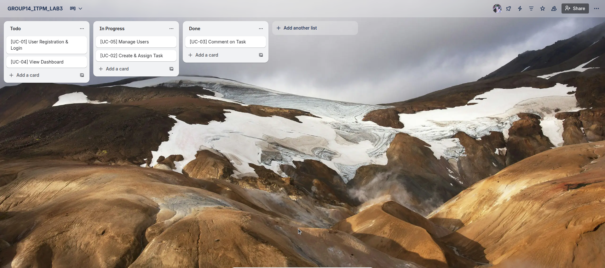Figure 1: Assign task for Use Case in Trello
NFR-01 Performance: Dashboard loads within 2 seconds.
NFR-02 Security: Uses HTTPS and JWT for authentication.
NFR-03 Usability: Responsive, intuitive design for small screens.
NFR-04 Reliability: System uptime ≥ 99%.
NFR-05 Maintainability: Modular React components; RESTful API structure.

3.4 Risks & Mitigation
R-01 Missed deadlines – Set clear milestones and use Trello deadlines.
R-02 Data loss – Implement automatic database backups.
R-03 Security flaws – Use secure password hashing and input validation.
R-04 Scope creep – Lock MVP scope and track change requests.
R-05 Poor testing – Implement test plans and QA checklist.

4. Traceability Matrix
Requirement ID | Description | Type | Trello Card Title | Status
FR-01 | User Registration & Login | Functional | [Auth] User Authentication | Done
FR-02 | Task Creation & Assignment | Functional | [Task] Create & Assign Task | Doing
FR-03 | Dashboard Overview | Functional | [Dashboard] Overview & Analytics | Review
FR-04 | Comment System | Functional | [Comment] Discussion Thread | Backlog
FR-05 | Notifications | Functional | [System] Notifications Setup | Doing

5. Appendices
Glossary: Task – Unit of work; Dashboard – Project summary view; Notification – Alert triggered by updates.
References: Lab 2 document (Group 14), Trello Board (links per traceability table).

